Probability & Statistics

( AI&DS , AI&ML )

QUESTION BANK

Unit 3 (CO3)

1. 20% of items produced from a factory are defective. 6M

Find the probability that in a sample of 5 chosen at random : i. None is Defective.

Ii. One is Defective.

Iii .P(1<X<4)

2. A Hospital switch board receives an average of 4 Emergency calls in a 10 minute interval. What is the probability that : 6M

i. There are atmost 2 emergency calls in 10 minutes interval.

ii. There are exactly 3 emergency calls in 10 minutes interval.

3. Fit a binomial distribution to the following frequency distribution : 6M

|  |  |  |  |  |  |
| --- | --- | --- | --- | --- | --- |
| x: | 0 | 1 | 2 | 3 | 4 |
| f: | 28 | 62 | 46 | 10 | 4 |

4. If X is a poisson variate such that 3P(X=4)=1/2 [P(X=2)]+P(X=0).Find : 6M

i. The mean of x.

ii. P(X<=2).

5. In a normal distribution 7% of items are under 35 and 89% are under 63.Determine the Mean and Variance of the distribution. 6M

6 .If the Mass of 300 students are normally distributed with mean 68 kgs and S.D 3 kgs . How many students have Mass :

i. Greater than 72 kgs. 6M

ii. Less than or equal to 64 kgs.

iii. Between 65b and 71 kgs inclusive.

Unit 4 (CO4)

1)A population consists of five numbers 2,3,6,8 and 11. Consider all possible samples of size two which can be drawn with replacement from this population. Find 12M

a. The mean of the population.

b. The Standard Deviation of the population.

c. The mean of sampling distribution of means .

d. The Standard deviation of the sampling distribution of means.

(2). A population consists of 5,10,14,18,13,24. Consider all possible samples of size two which can be drawn with replacement from the population. Find 12M

a. The mean of the population.

b. The Standard Deviation of population.

c. The mean of sampling distribution of means.

d. The Standard deviation of sampling distribution of means.

(3). A population consists of six numbers 4,8,12,16,20,24. Consider all possible samples of size two which can be drawn with replacement from the population .Find 12M

a. Population Mean.

b. The population standard deviation.

c.The mean of sampling distribution of means.

d.The Standard deviation of the sampling distribution of means.

(4). Sample of size 2 are taken from the population 1,2,3,4,5,6..

i.With replacement. ii.Without replacement. Find: 12M

a. The mean of population.

b. Standard deviation population.

c. The mean of the sampling distribution of means.

(6)(a). When a sample is taken from a infinite population. What happens to the standard error of the mean if the sample size is increased from 800 to 200. 4M

(6)(b).A random sample of size 300 is taken from an infinite population having the mean µ=76 and the variance 256.What is the probability that sample mean will be between 75 and 78 ? 8M

(7)(a). What is the size of smallest sample required to estimate an unknown proportion to within a max error of 0.06 will atleast 95% confidence ? 6M

(7)(b). Construct 99% confidence interval for population mean $μ$ using the sample mean $\overline{X}=10$ of a random sample of size 200 with variance 4. 6M

(8)(a).What is the max error one can expect to make with probability 0.90 when using the mean of random sample of size n=64 to estimate the mean of population with variance 2.56 ?6M

(8)(b). A random sample of size 100 is taken from a population with mean 5.1. Given that the sample mean is 21.6 . Construct a 95% confidence interval for the population mean . 6M

(9)(a).Find 95% confidence limits for the mean of a normally distributed population from which the following sample was taken 15,17,10,18,16,9,7,11,13,14. 6M

(9)(b).Determine a 95% confidence interval for the mean of a normal distribution with variance 0.25, using a sample of n=100 values with mean = 212.3 6M

10(a).A random sample of 400 items is found to have mean 82 and Standard deviation of 18 . Find the maximum error of estimation at 95% confidence interval .Find the confidence limits for the mean. 6M

10(b).A Sample of size 300 was taken from a population whose variance is 225 and sample mean is 54. Construct 95% confidence interval for the mean. 6M

UNIT 5 (CO5)

1(a ) An ambulance service claims that it takes on the average less than 10 minutes to reach its duration in emergency calls. A sample of 36 calls has a mean of 11 minutes and the variance of 16 minutes. Test the claim at 0.05 level of significance. 6M

1(b).Experience had shown that 20% of a manufactured product is of the top quality. In one day’s production of 400 articles only 50 are of top quality. Test the hypothesis at 0.05 level. 6M

2(a).A sample of 64 students have a mean weight of 70 kgs. Can this be regarded as a sample from a population with mean weight 56 kgs and standard deviation 25 kgs. 6M

2(b).The mean time of a sample of 100 light tubes produced by a company is found to be 1560 hours with a population standard deviation of 90 hours. Test the hypothesis for $α$ = 0.05 that the mean life time of the tubes produced by the company is 1580 hours. 6M

3. The mean life of a sample of 10 electric bulbs (or motors) was found to be 1456 hours with standard deviation of 423 hours. A second sample of 17 bulbs (motors) chosen from a different batch showed a mean life of 1280 hours with standard deviation of 398 hours. Is there a significant difference between the means of two batches? 12M

4(a).In 64 randomly selected hours of production, the mean and the standard deviation of the number of acceptance pieces produced by an automobile stamping machine are $\overline{x}$ = 1.038 and $σ$ = 0.146 at the 0.05 level of significance does this enable us to reject the null hypothesis $μ$ = 1000 against the alternative hypothesis $μ$ > 1000? 6M

4(b).A manufacturer claims that only 4% of his products are defective. A random sample of 500 were taken among which 100 were defective. Test the hypothesis at 0.05 level. 6M

5(a).Random samples of 400 men and 600 women were asked whether they would like to have a flyover near their residence. 200 men and 300 women were in favour of the proposal. Test the hypothesis that proportions of men and women in favour of the proposal are same at 5% level. 6M

5(b).In two large populations, there are 30% and 25% respectively of fair-haired people. Is the difference likely to be hidden in samples of 1200 and 900 respectively from the two populations? 6M

6. Given the following information relating to two places A and B. Test whether there is any significant difference between their mean wages: 12M

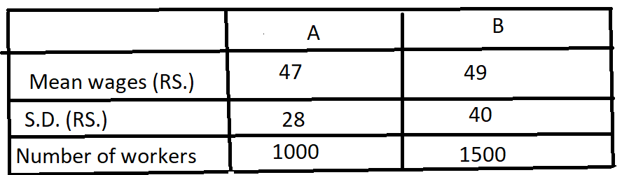

7. Test the significance of the difference between the means of the samples using the following data. 12M

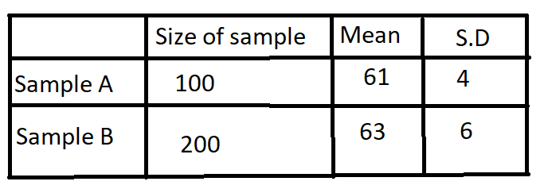

1. A random sample of 10 boys had the following I.Q’S : 70 ,120, 110, 101, 88, 83, 95, 98, 107 and 100. 12M
2. . Do these data support the assumption of a population mean I.Q of 100 ?
3. . Find a reasonable range in which most of the mean I.Q. values of sample of 10 boys lie.
4. .Two independent samples of sizes 8 and 7 respectively had the following values.

|  |  |  |  |  |  |  |  |  |
| --- | --- | --- | --- | --- | --- | --- | --- | --- |
| S-I | 9 | 11 | 13 | 11 | 15 | 9 | 12 | 14 |
| S-II | 10 | 12 | 10 | 14 | 9 | 8 | 10 | -- |

Is the difference between the means of the samples significant ? 12M

|  |  |  |  |  |  |  |  |  |  |  |  |  |  |  |  |  |  |  |  |  |  |  |
| --- | --- | --- | --- | --- | --- | --- | --- | --- | --- | --- | --- | --- | --- | --- | --- | --- | --- | --- | --- | --- | --- | --- |
| 1. .To examine the hypothesis that the husbands are more intelligent than the wives, an investigator took a sample of 10 couples and administered them a test which measure the I.Q. The results are as follows: 12M  |  |  |  |  |  |  |  |  |  |  |  | | --- | --- | --- | --- | --- | --- | --- | --- | --- | --- | --- | | Husbands | 117 | 105 | 97 | 105 | 123 | 109 | 86 | 78 | 103 | 107 | | Wives | 106 | 98 | 87 | 104 | 116 | 95 | 90 | 69 | 108 | 85 |   Test the hypothesis with a reasonable test at . |